Santa Fe County & Tesuque Valley Planning Committee

Tesuque Community Proposed Amendments 10.19

2019 Proposed Amendments 10.19

SECTION I: INTRODUCTION

Purpose & Intent

The purpose of the 2019 Tesuque Valley Community Plan Update is to articulate the community’s vision and goals for the future, identify and document past and recent history, describe current conditions and major trends and provide recommendations and strategies for achieving the community’s vision and goals. The purpose of the 2019 Tesuque Valley Community Plan Update is to amend the plan for consistency with the Santa Fe County Sustainable Growth Management Plan (SGMP). The plan update will also provide a foundation for consistency between the Tesuque Community Plan and the Tesuque Community District Overlay in the Sustainable Land Development Code (SLDC). The 2019 Tesuque Community Plan Update is intended to provide a framework for the development of an overlay district for the Tesuque Community District through the Sustainable Land Development Code (SLDC). The plan articulates the vision for the community and provides guidance for design standards and uses, locations and intensity of development in order to enhance rural development patterns, protect scenic features and environmentally sensitive areas and accommodate the anticipated natural growth of the community. When adopted, it will amend the Santa Fe County Sustainable Growth Management Plan as a Community Plan.

New Challenges and Opportunities

FLOODING (Need to add language here)

Planning History & Community Outreach (Need to reflect 2019 Plan Amendment Process

Related Plans, Policies and Programs (Need to Update to reflect current plans, policies and programs)

State and Federal Agencies:
- Office of the State Engineer and Interstate Stream Commission- Responsible for administering the state's water resources. The agency has had a major role in contributing to the following:
  - Jemez y Sangre Regional Water Plan- The Jemez y Sangre Regional Water Plan projects future water usage and identifies strategies to provide adequate water supply across Los Alamos County and portions of Santa Fe, Sandoval, and Rio Arriba County.
  - Aamodt Settlement-
  - Santa Fe County, the Pueblos of Nambe, Pojoaque, San Ildefonso and Tesuque, the State of New Mexico, the United States, and the City of Santa Fe (“Settling Parties”) entered into a Settlement Agreement, which was approved and adopted by the Federal Court in 2016. The final judgment and decree was filed on July 14, 2017. The Agreement primarily concerns the water rights of the four Pueblos in the Aamodt adjudication within the Nambé-Pojoaque-Tesuque basin, but it also makes certain beneficial concessions regarding non-Pueblo water rights. The goal of the Settlement Agreement is to resolve the Pueblos’ water rights claims while preserving existing non-Pueblo water uses. This goal is achieved, in part, by bringing more water into the Pojoaque Basin through the construction of a regional water system for both Pueblo and non-

Demographics, Housing and Employment

According to recent census data, total population growth for the Tesuque Census Designated Place, (CDP) which is congruent with the planning area, has been relatively low or negative as compared to the County. Between 2000 and 2010 the population increased from 909 to 925 people representing a 2% increase over the decade. The year-round population has actually decreased from 2010 to 2017, even though the number of dwelling units has increased, due to decreased household size, and a greater proportion of seasonal (as opposed to year-round) dwelling units.
However, growth in the number of housing units is extremely high for the County. According to the census data, the numbers of residential units increased by 33% from 2000 to 2010 while the number of vacant housing units increased by 131%. From 2010 to 2017, the number of residential units increased 6.8% (49 units), however the number of families decreased from 221 in 2010 to 193 in 2017 (13% decrease). This most likely represents a substantial increase in vacation and or second homes.

Residents of Tesuque have grown older in the last decade. In 2010, 23% of the population was 65 years or older representing a 52% increase since 2000 and less than 9% of the population was under the age of 18 representing a 41% decrease since 2000. In 2017, 35% of the population was 65 years or older and the population under the age of 18 went down to 8%, the median age being 59 years old. Continued increases in the elderly population may increase the need for services in the area.

According to American Community Survey 5-year estimates, Tesuque has lower unemployment rates and a larger percentage of its residents in the workforce than Santa Fe County as a whole, including the City of Santa Fe. Tesuque’s 2010 median annual household income of $105,538 was nearly double the City and County median annual household income of $53,698. The median household income in 2017 went down to $70,563. However, although Tesuque may be regarded as affluent, 18% of households in the community have incomes of less than $14,999. The community recognizes diversity as an indicator of a healthy, resilient community and is strongly committed to maintaining economic diversity.

Major employers in the planning area are listed below. In addition to these employers, there are a number of Tesuque home businesses in the district. Key businesses and institutions in in the planning area is as follows:
- Bishops Lodge Resort
- Tesuque Elementary School-
- Santa Fe Mountain Center-
- Shidoni Galleries-
- Tesuque Glass Works-
- Tesuque Village Market-
- Green Galleries-
- Holistic Center-
- Post Office
- El Nido
- San Ysidro Church

Existing Land Use Categories
The Tesuque District Land Use Categories were developed through the 2015 SLDC process in accordance with the Sustainable Growth Management Plan (SGMP) Use Categories. The Tesuque District Land Use Plan includes six Land Use Categories: Rural Residential, Residential Fringe, Residential Estate, Residential Community Traditional Community, and Public/Institutional.

Rural Residential. The purpose of this district is to provide for the development of single family homes on large lots, either individually or as part of rural subdivisions; to preserve the scenic and rural character of the County; to provide consolidated open space and agricultural lands; and to recognize the desirability of carrying on compatible agricultural operations and home development in areas near the fringes of urban development while avoiding unreasonable restrictions on farming or ranching operations. This designation applies to two areas encompassing approximately 420 acres that cover large residential lots located in the foothills which border Santa Fe National Forest. This zoning district is characterized by less level, buildable area and more sloping terrain. Most of the area has good tree cover, with piñon and juniper trees predominant in the landscape. Many of the residential lots that are less than 10 acres are associated with land set aside as conservation easements or permanent open space. Uses limited to single-family residential development, agricultural related uses and home occupations that are residential in scale.

Residential Fringe. The purpose of this district is to designate areas associated primarily with contemporary residential subdivisions that were established off the valley floor in the surrounding piñon/juniper covered hills. The East Ridge District encompasses approximately 185 acres in the northeast portion of the plan area and abutting the Santa Fe National Forest. The West Ridge District encompasses approximately 1025 acres along the western boundary of the plan area abutting highway US 285. Uses are limited to single-family residential development, agricultural related uses and home occupations that are residential in scale.

Residential Estate. The purpose of this district is to designate properties that are situated on a flat ridge above the valley floor adjacent to Bishop’s Lodge Hills Subdivision and accessed by either Mama Kay Way or Eccola Lane or Bauer Road. This area should continue to evolve as a primarily low-density single-family residential district with appropriate infrastructure and options for clustering in conjunction with contiguous common areas or conservation easements.

Residential Community. The purpose of this district is to recognize the area along both the Big and Little Tesuque Rivers as the green heart of the plan area and the feature that differentiates Tesuque from other areas. It encompasses more than 850 acres and represents much of Tesuque’s historic and agricultural past, as well as the community’s hopes for continued agricultural use in the future. Preservation of this area as rural and open is tied to the need to keep the lands available and suitable for pastures, orchards and other agricultural uses; and for the preservation of the acequias. Uses are limited to single-family residential development, agricultural related uses, home occupations, and small scale commercial uses centrally located near the intersection of Bishop’s Lodge Road and Tesuque Village Road. (See Tesuque Rural Commercial Overlay).

Traditional Community. The purpose of the TCD TC district is to continue to reflect the unique historic development patterns of the old village with a mixed pattern of lot sizes and shapes and housing types. This district is primarily single-family residential district consistent with historic options for compact residential development including clustered housing, family compounds, and accessory dwelling units. Community facilities, institutional uses, agricultural uses, and home occupations that are residential in scale are appropriate in the district. The TCD Traditional Community district accommodates traditional community patterns, preserves historic and cultural landscapes, and protects agricultural uses, including agricultural found in traditional communities with acequia systems, from encroachment by development.

Public Institutional. The purpose of the TCD PI district is to accommodate governmental, educational, and non-profit or institutional uses, including public or community parks and recreation facilities, and public, non-profit, and institutional residential uses, but excluding any such uses of an extensive heavy industrial character.

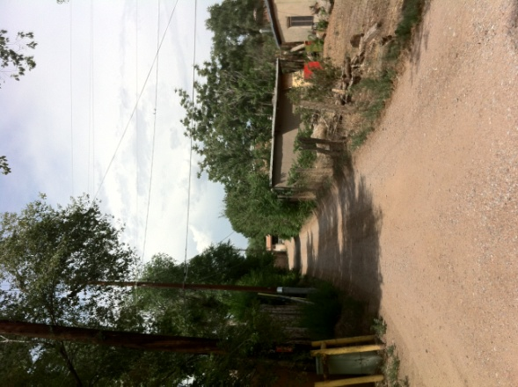
SECTION II: PLAN ELEMENTS

Scenic Corridor and Roads (Being Updated)

Figure 1 Scenic Corridor Schematic Plan

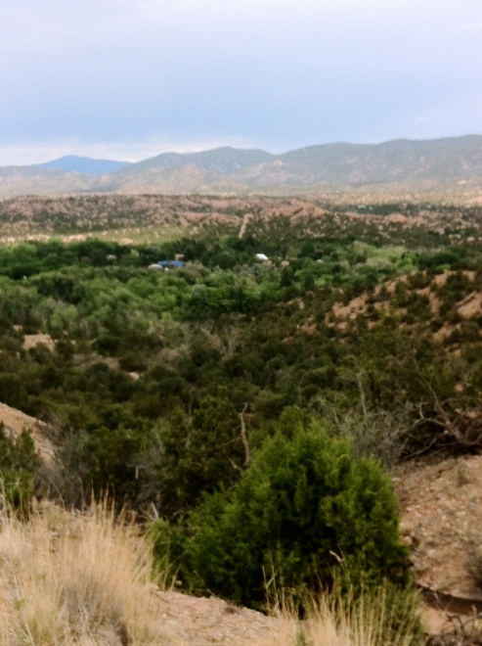
Land Uses, Densities & Development Patterns
The traditional community pattern is based on the acequia systems, small farms, rural roads, the natural terrain, small scale buildings and self-sufficiency. New development and land uses should reflect the existing unique character of Tesuque and support aging in place, rural lifestyles and the ability to enjoy the quiet tranquility of this place.

Introduction

This section identifies issues, objectives and strategies pertaining to land uses, densities, development patterns, home occupations and code enforcement. The overall goal of preserving the existing land uses, development patterns and densities stems from the consistent refrain of “we want Tesuque to remain the way it is today!”

It provides land use designations and map, (see page 18) and corresponding general provisions to address the following issues:

- Review of the land use element of the SGMP and the Rio Tesuque Community Land Use Plan revealed the need to establish and map land use designations that more closely reflect existing land uses, densities and development patterns.
      - Home occupations and non-conforming uses over the years have evolved into commercial developments without appropriate oversight of impacts to adjacent property owners and the community at large.
      - Community has identified concerns regarding enforcement of nuisance issues (SLDC Section 1.2 & 1.4) which are being addressed through regular coordination with County staff.
      - There is an opportunity to support traditional family living arrangements, aging in place and mixed income objectives without additional land divisions by allowing “accessory dwelling units” that are appropriately located, sized and provided with high performing septic /wastewater treatment.
      - There is an opportunity to encourage and incentivize the preservation and assembly of agricultural and open space lands.

Land Use Map & Designations
The land use designations identified through the Sustainable Growth Management Plan and the 2019 Tesuque Community Plan are identified on the land use map and provide a general framework and guidance for future land use decisions.
The map and designations delineate areas based on topography, existing lot sizes and patterns, compatible land uses, and appropriate locations for commercial and mixed-use development. General uses, densities, and development standards are described. Development types, such as family compounds, accessory dwelling units and clustered developments are identified for some of the designations with the anticipation that development standards will be drafted as part of the ordinance.

TVCP Griego Hill Traditional Village District
TVCP Traditional Community

Griego Hill is probably the oldest continually occupied residential area in Tesuque and now its most densely settled. The elevated area comprises approximately 72 acres and is located close to the intersection of Tesuque’s two main roads, the elementary school and the small commercial area. As such, it is the center of the valley and the village.

The homes on Griego Hill are served by a community water system that was established in 1974, as the result of an early planning effort that had identified the need for a clean water source as family holdings had been divided into increasingly smaller lots.

The Griego Hill Traditional Village District should continue to reflect the unique historic development patterns of the old village with a mixed pattern of lot sizes and shapes and housing types. It should remain as a primarily single-family residential district consistent with historic options for compact residential development including clustered housing, family compounds and accessory dwelling units. This plan envisions continued uses of community facilities, institutional uses, agricultural uses, and home occupations that are residential in scale.
(*Need to clarify area in Tesuque Commmunity Overlay)

The Land Use analysis has identified the average lot sizes for the TVCP TCD as approximately one half acre per lot. In order to maintain rural character and ensure that septic tanks will not contaminate ground water, new land divisions should not create lots that are less than 3/4 of an acre.

New development on existing lots of less than ¾ acres should encourage high performance septic systems or connection to a community wastewater system to address potential environmental impacts.

Accessory dwelling units are appropriate for this area and should reflect the character and scale of the community.

The El Nido Restaurant is a commercial establishment located in this land use category. Any new commercial uses or expansion of existing non-residential uses should meet objectives of the Traditional Commmunity land use category.

This land use category supports building structures height of 26 feet on slopes less than 15% allow flexibility of floor plan design and architecture while maintaining integrity of scale and height for consideration of overall impact on viewsheds. Structures with a second story should incorporate architectural features to maintain the character of the area.

New development on slopes greater than 15% should be consistent with County Terrain Management standards.

Performance based setbacks reflecting the historic patterns of Griego Hill should be established as part of the future zoning regulations.

TVCP Residential Community

The area along both the Big and Little Tesuque Rivers is recognized as the green heart of the plan area and the feature that differentiates Tesuque from other areas. It encompasses more than 850 acres and represents much of Tesuque’s historic and agricultural past, as well as the community’s hopes for continued agricultural use in the future. Preservation of this area as rural and open is tied to the need to keep the lands available and suitable for pastures, orchards and other agricultural uses; and to the preservation of the acequias.

TVCP Residential Community (RES-C) District is an appropriate area for residential, agricultural, home occupations that help engender the character of the community. Small scale commercial uses are also appropriate near the intersection of Bishop’s Lodge Road and Tesuque Village Road. Any new commercial uses or expansion of existing non-residential uses should meet objectives of the TVCP RES-C.

Average lot size is approximately 2.42 acres with the majority of lots, (51% )being greater than 1.5 acres.

Preservation of open space and agricultural land in residential community is important to maintain the area’s character including open space, grazing, agricultural lands, trail easements, historic and cultural sites.

Accessory dwelling units are appropriate for this area and should reflect the character and scale of the community.

This land use category supports building structures height of 26 feet on slopes less than 15% allow flexibility of floor plan design and architecture while maintaining integrity of scale and height for consideration of overall impact on viewsheds. Structures with a second story should incorporate architectural features to maintain the character of the area.

New development on slopes greater than 15% should be consistent with County Terrain Management standards.

Performance based setbacks reflecting the historic patterns of the area should be considered as part of the future zoning regulations.

TVCP Residential Estate

The Residential Estate District is designated for properties in the Planning Area that are situated on a flat ridge above the valley floor adjacent to Bishop’s Lodge Hills Subdivision and accessed by either Mama Kay Way or Eccola Lane or Bauer Road.

The area is comprised of residential properties which have recently been subdivided through the family transfer process. Lot sizes currently range between 1.4 acres to 7.5 acres with an average lot size of approximately 3.2 acres.

This area should continue to evolve as a primarily low-density residential area with appropriate infrastructure and options for clustering in conjunction with contiguous common areas or conservation easements. Accessory dwelling units are appropriate for this area and should reflect the character and scale of the community.

The TVCP Residential Estate (RES-E) area is a transition zone between the valley and the upper elevations of the TCD. Lot sizes in this area should reflect the existing development pattern.

Building envelopes and setbacks should be established on parcels to minimize the visibility of development from the valley floor and Bishop’s Lodge Road and to provide a natural buffer between developments.

New development on slopes greater than 15% should be consistent with County Terrain Management standards.

TVCP East and West Ridge Districts
TVCP Residential Fringe

The East and West Ridge Districts are designated for areas associated primarily with contemporary residential subdivisions that were established off the valley floor in the surrounding piñon/juniper covered hills. Most of these subdivisions have covenants covering minimum lot sizes, buildable areas, utility easements, egress and ingress easements, building heights and setbacks. The East Ridge District encompasses approximately 185 acres in the northeast portion of the plan area and abutting the Santa Fe National Forest. The West Ridge District encompasses approximately 1025 acres along the western boundary of the plan area abutting highway US 285.

Uses should continue to be residential development, agricultural related uses and home occupations that are residential in scale.

Lot sizes in this area should reflect the existing development pattern. Compact residential development in conjunction with contiguous common areas or conservation easements should be encouraged.

Accessory dwelling units are appropriate for this area and should reflect the rural character and scale of the community.
New development on slopes less than 15% should allow additional height for flexibility of floor plan design and architecture while maintaining integrity of scale and height for consideration of overall impact on viewsheds.

New development on slopes greater than 15% should be consistent with County Terrain Management standards.
Building envelopes and setbacks should be established on parcels to provide a natural buffer between developments.

Areas in Residential Fringe have notable terrain management challenges. Slopes are steeper and there is less tree cover and more exposed sub-soils. Extra care should be given to the planning of driveways and buildable area so as to prevent future erosion.

TVCP Foothills District
TVCP Rural Residential

This designation applies to two areas encompassing approximately 420 acres that cover large residential lots located in the foothills which border Santa Fe National Forest. There is less level, buildable area and more sloping terrain. Most of the area has good tree cover, with piñon and juniper trees predominant in the landscape.

Average lot size is approximately 12 acres with 46% of the lots being greater than 10 acres. Many of the residential lots that are less than 10 acres are associated with land set aside as conservation easements or permanent open space. In order to reflect existing development patterns and natural transition area from the valley floor to the Santa Fe National Forest, new land divisions and development should have a maximum density of 1 unit per 10 acres or greater.

TVCP Rural Residential (RUR-R) District is an appropriate area for residential, agricultural, home occupations that help engender the character of the community.

Accessory dwelling units are appropriate for this area and should reflect the rural character and scale of the community.
New development on slopes less than 15% should allow additional height for flexibility of floor plan design and architecture while maintaining integrity of scale and height for consideration of overall impact on viewsheds.

New development on slopes greater than 15% should be consistent with County Terrain Management standards.
Building envelopes and setbacks should be established on parcels to provide a natural buffer between developments.

TVCP Rural Commercial Overlay

The TVCP Rural Commercial Overlay accommodates the expansion or new development of business, commercial, higher density residential and service-related activities in the Village Core area. It covers properties that are appropriately located and have adequate frontage and access onto public roads with existing capacity to accommodate more intensive development. The intent of the overlay is to supplement standards of the underlying land use designation for mixed-uses in order to support community goals for economic development, self-sufficiency, sustainability and aging in place while maintaining residential scale and rural character of the plan area.

This category is designated for two different areas:

Area A:
Approx. 17 acres
This area is centrally located and covers lots or portions of lots with established/ historic commercial land uses, and/or frontage on Bishop’s Lodge Road and/or Tesuque Village Road within the village core.

The area is envisioned to continue as mixed-use village center supporting neighborhood scale retail and commercial uses, community facilities and open space.Due to the higher density and intensity of the area, the following improvements are recommended:
- Improved wastewater treatment: This may be in conjunction with a future community wastewater treatment facility, sanitation district or satellite system that serves the elementary school and homes located in the Griego Hill Traditional Village District.
- Shared parking and circulation plan: A shared parking and circulation master plan should be developed so that traffic and parking from existing and new businesses is efficient, organized and limits impacts to surrounding areas.
- Improvements to the RTD Blue Route: A transit stop for the RTD Blue route has recently been established in Area A providing convenient public transit options to and from Santa Fe for plan area residents. Improvements to the transit stop that provide shade and seating are needed and should be addressed as part of the pedestrian circulation plan: See Error! Reference source not found. beginning on page Error! Bookmark not defined..
- Community Center: See Community Facilities page Error! Bookmark not defined.
- Community outdoor space and / or small passive park: See Community Facilities page Error! Bookmark not defined.

Area B:
Approx. 9 acres

This area is located along Tesuque Village Road just east of the interchange with US 285 on approximately 9 acres of vacant land that abuts public right-of-way on three sides; Tesuque Village Road on the south and east and Highway US 285 on the west. This area functions as a gateway to Tesuque. As such, future development of the area must be scaled to its rural setting. The area is envisioned to be appropriate for neighborhood-scaled and neighborhood-oriented mixed uses, including commercial offices, live work units, studios, restaurants, retail of primarily locally produced goods, community services, recreation amenities.
It is not appropriate for travel services, highway oriented development or retail where the majority of goods are not produced locally. It should be noted that there are likely major constraints to development due to steep slopes and a large arroyo cutting through the site. On-site density transfer should be considered for areas primarily left in a natural state.

General Provisions for Areas A & B:

Although this category allows a mixture of land uses, there should be controls intended to minimize or buffer any nuisances caused by new or expanded development.

Development in the TVCP Rural Commercial Overlay should be designed to complement the surrounding residential pattern with neighborhood scaled business, services, and commercial establishments including restaurants and community facilities.

Due to the rural and residential character of the village core and its proximity to both the Tesuque Elementary School and the Rio Tesuque; high intensity industrial, manufacturing, processing or storage activities are not appropriate for this area.

TVCP Community Facilities Overlay
TVCP Public Institutional

The Tesuque Elementary School, the Tesuque Volunteer Fire Station, the US Post Office and San Ysidro Mission Church are vital community facilities that provide essential services to our rural community. Expansion and redevelopment that meets community needs should be allowed at appropriate scale.

In order to fit in with surrounding residential development, dimensional standards of underlying designation should be applied.

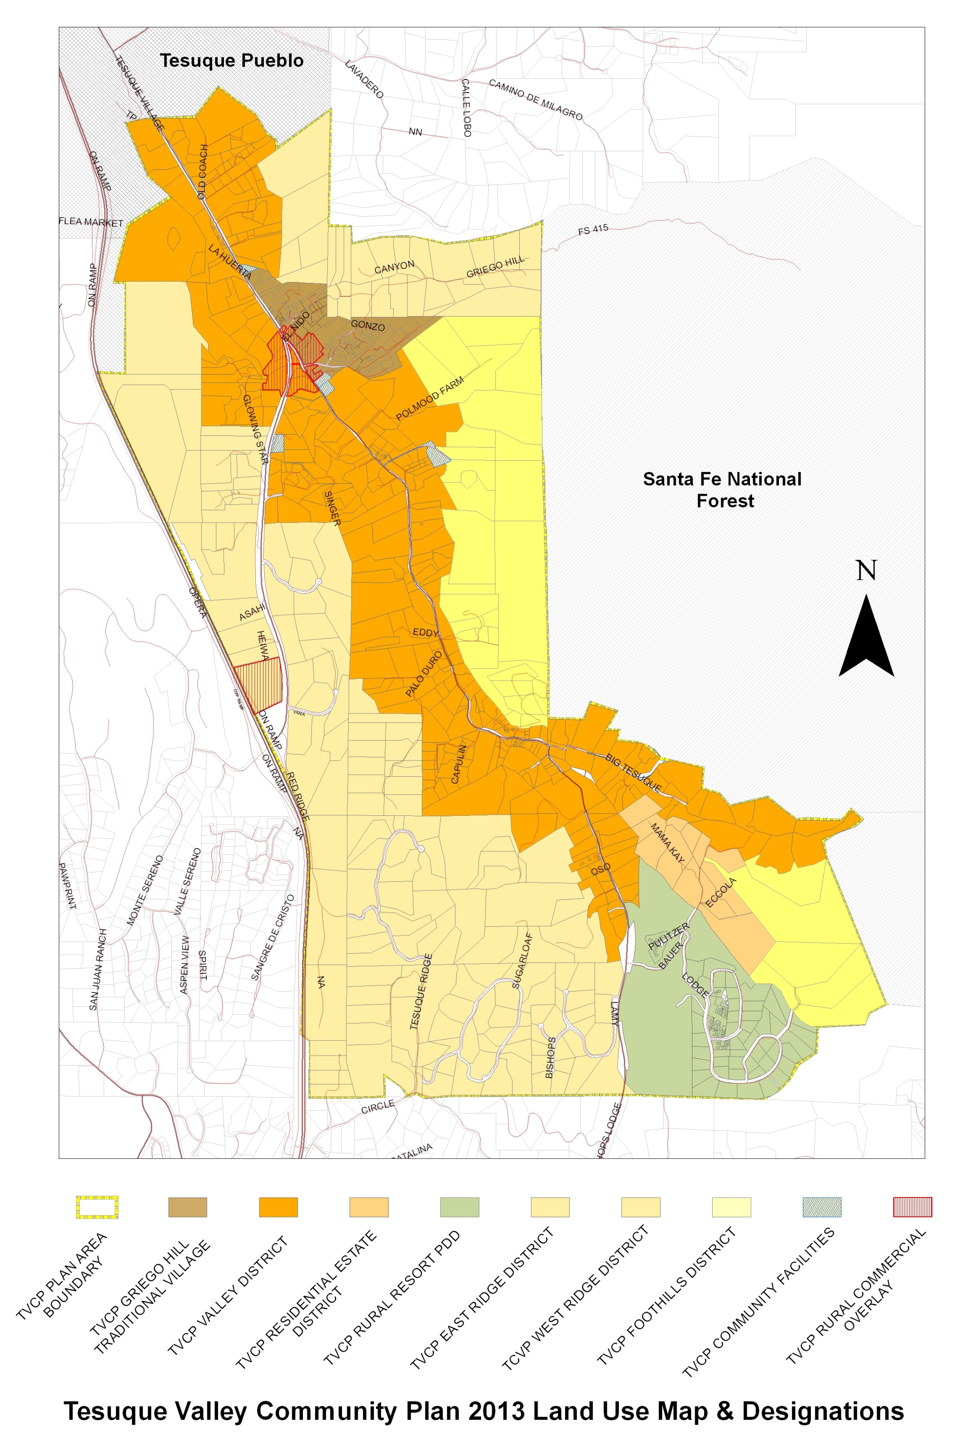
Figure 2 Future Land Use Map & Designations

Density and Minimum Lot Sizes
New development and land uses should reflect the existing unique character of Tesuque. The existing densities and lot sizes are based on topography and historic patterns and greatly contribute to our rural lifestyles and the ability to enjoy the quiet tranquility of this place. Density variances should be discouraged, except:

- Where density transfers are used to protect sensitive lands or preserve open space or agricultural lands and gross density is maintained.

Home Occupations
Home occupations in Tesuque contribute to making Tesuque a self-sufficient and lively community. Existing home occupations include but are not limited to:
- Bookkeeping services
- Counseling
- Construction company home office
- Consulting businesses
- Photographers studios
- Artists’ studios
- Craft production
- Architects offices
- Septic services home office
- Horse boarding services
- Distillers and vintners

Most home occupations in Tesuque are residential in scale and have little impact on their neighbors.

No-impact and low-impact home occupations should be allowed in all land use designations.
This plan supports home occupations that provide economic opportunities for residents that are appropriate for residential and agricultural areas.

Procedures should be adopted along with appropriate staffing levels to increase County oversight needed to ensure road construction adheres to regulations and design standards.

Accessory Dwelling Units
To support aging in place, multi-generational family living arrangements and traditional development patterns, accessory dwelling units should be allowed at appropriate scale to maintain community character and to protect the environment.

Floodplain
The existence of complex floodplain conditions in the TVCP planning area has led to community concerns regarding federal and local regulations. This plan envisions a cooperative approach to examining how floodplain regulations may be reviewed to ensure public safety as well as accurate depictions of developable areas.

Conservation Area Continuity
Conservation areas and other easements are appropriate for the preservation of agricultural land, protection of river, arroyos or trail corridors and should interconnect to adjacent sites of a similar nature, as practicable.

Dark Night Sky
Provide regulations for outdoor lighting that will:
- Permit use of outdoor lighting that does not exceed the minimum levels specified in IES recommended practices for nighttime safety, utility, security productivity and enjoyment
- Minimize adverse offsite impacts lighting such as trespass, and obtrusive light.
- Curtail light pollution; reduce sky glow and improve the nighttime environment for astronomy.
- Conserve energy and resources to the greatest extent possible

Lot Coverage
Lot coverage for residential uses in the plan area vary quite a bit. In general the smaller the lots size the higher the lot coverage. To support the traditional development pattern, rural character and a healthy watershed, regulations for lot coverage should vary with lot size and pertain to permeable surfaces.

Natural Landscaping
This plan envisions the use of native vegetation and natural landscaping to the extent practicable. Native vegetation should be preserved on development sites and local native plants used for landscape buffers and screening, as appropriate.

Non-Conforming Uses

The existence of non-conforming uses in the TVCP planning area has led to community concerns regarding potential impacts to the community and the environment. This plan envisions a cooperative approach to examining how non-conforming use regulations may be reviewed to ensure that appropriate scale and intensity of use is maintained for the community’s benefit.

Enforcement
A proactive approach versus a reactive to enforcement is needed to avoid prolonged conflicts between and among properties owners and the County.

Strategy: Community members will continue to schedule meetings with Santa Fe County staff to proactively address code enforcement concerns and proactive engagement on these issues.

Figure 3 Agriculture & Acequia Study Map

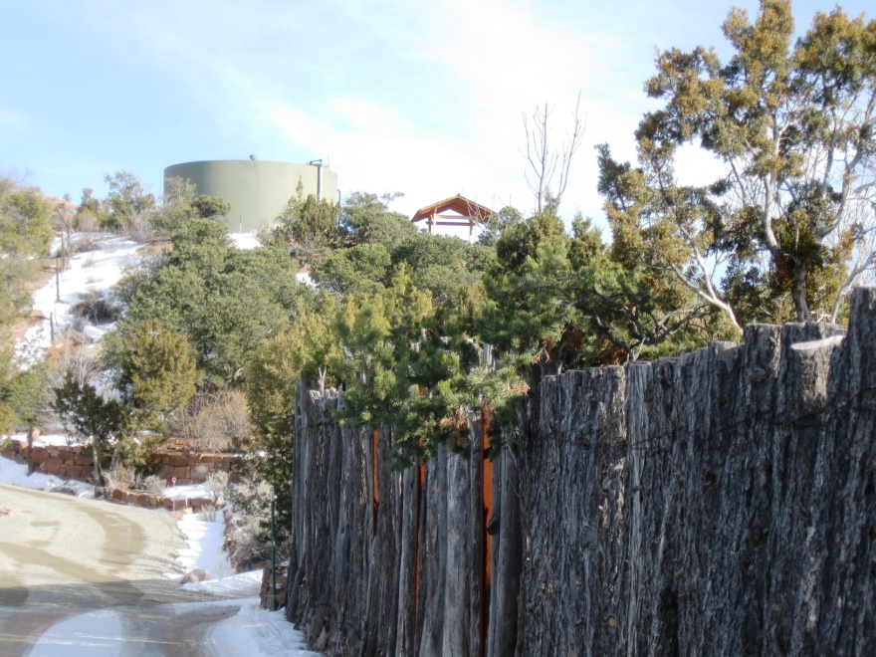

Water Supply and Wastewater Treatment
Tesuque’s quality of life depends on adequate water quality and water quantity. (UPDATE)

Figure 5 Water & Wastewater Study Map

SECTION III: IMPLEMENTATION (UPDATE)

Strategic Work Plan (UPDATE)

Introduction

The spirit of collaboration and cooperation that carried Tesuque through the plan update process will be vital to implementing the updated community plan. The process of collaborating to implement the community goals established in this plan is as important as the goals themselves.

Implementation Matrix
The Implementation Matrix lists many of the strategies of the plan, and lays out the responsible entity, timing of implementation and potential funding sources, where relevant. Recommended zoning regulations will be implemented with adoption of Sustainable Land Development Code. Capital Improvement Projects will follow the standard process for submittal, evaluation and adoption by the County. The remaining strategies are voluntary initiatives, and may involve collaboration of the community groups, Tesuque Valley Association with County departments, other public agencies or organizations. The Tesuque Valley Association should create an Implementation Task Force to organize committees to be responsible for coordinating the implementation of each of these strategies and activities.

